LAB REPORT # 01


Submitted by:

Submitted by:

Name | Registration No.
Muhammad Abdullah | FA24-BSE-042
Submitted to: Sir Raheel Ahmed
Course Code: EEE240
Dated: FEB 27 , 2026.

DEPARTMENT OF COMPUTER SCIENCE
COMSATS UNIVERSITY ISLAMABAD,
ISLAMABAD CAMPUS

Introduction to Basic Logic Gate and Proteus Simulation
Objectives:
- Part 1: To know about the basic logic gates, their truth tables, input-output characteristics and analyzing their functionality. Introduction to logic gates.
- Part 2: Learn to use Proteus Software for Simulation of Digital Logic Circuits.

In-Lab Task:

Part 2 - Proteus (Simulation Software) Proteus has many features to generate both analog and digital results over a virtual environment. However, this lab will focus on tools that will be used in digital schematic designs and verification of basic logic gates.

For NOT:

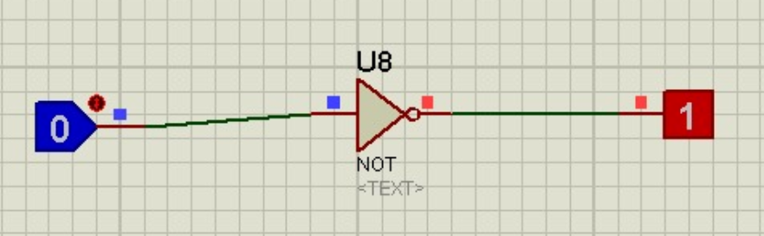

For OR:
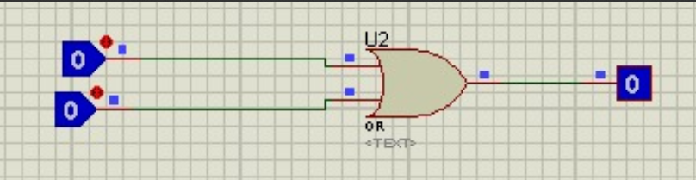

For NOR:
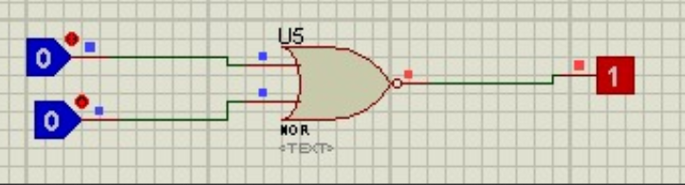

For NAND:

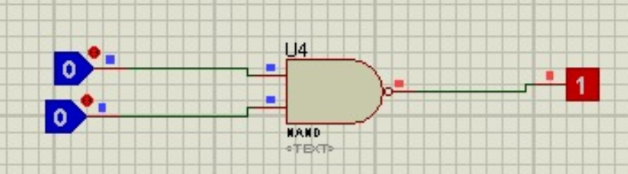

For AND:

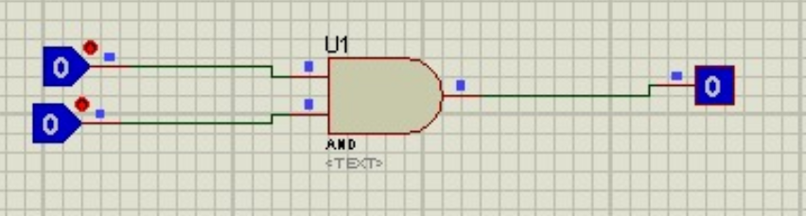

For XOR:

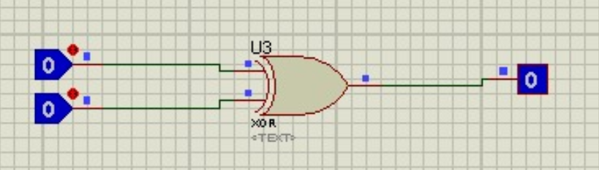

For XNOR:

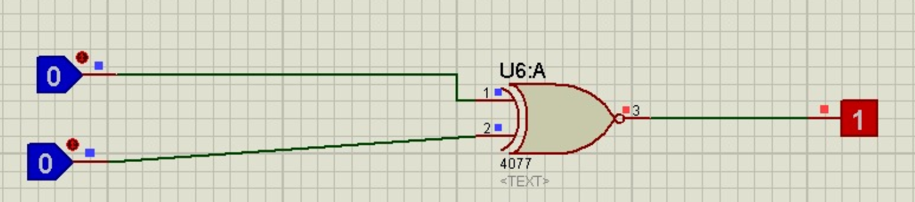

INPUTS |  | OUTPUTS
A | B | AND | OR | XOR | NAND | NOR | XNOR
0 | 0 | 0 | 0 | 0 | 1 | 1 | 0
0 | 1 | 0 | 1 | 1 | 1 | 0 | 1
1 | 0 | 0 | 1 | 1 | 1 | 0 | 1
1 | 1 | 1 | 1 | 0 | 0 | 0 | 0

NOT GATE
INPUT | OUTPUT
A | B
0 | 1
1 | 0

